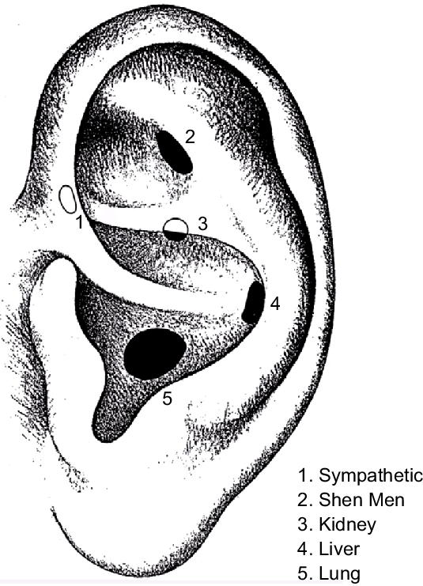

Acupuncture treatment with Paul

Parents Support Link is incorporating auricular acupuncture into our client's treatment plan. This addition aims to enhance their well-being by promoting better sleep, alleviating anxiety, relieving muscle tension, enhancing digestion, and improving circulation.
The sessions are scheduled to take place at the PSL office in the cabin with Paul every Friday. To reserve your spot, please reach out to Babs at Admin via email at admin@pslcharity.org.uk or call 02380399764. Please make sure to contact us soon, as we have a maximum capacity of eight participants for this session, and spaces are filling up quickly. Each session will commence at 10 am and conclude by 11:30 am.

We look forward to hearing from you!

